Simplified Circuit using K-Maps and Don’t cares.
 | W | X | Y | Z |  | A | B | C | D | E | F | G
0 | 0 | 0 | 0 | 0 |  | 1 | 1 | 1 | 1 | 1 | 1 | 0
1 | 0 | 0 | 0 | 1 |  | 0 | 1 | 1 | 0 | 0 | 0 | 0
2 | 0 | 0 | 1 | 0 |  | 1 | 1 | 0 | 1 | 1 | 0 | 1
3 | 0 | 0 | 1 | 1 |  | 1 | 1 | 1 | 1 | 0 | 0 | 1
4 | 0 | 1 | 0 | 0 |  | 0 | 1 | 1 | 0 | 0 | 1 | 1
5 | 0 | 1 | 0 | 1 |  | 1 | 0 | 1 | 1 | 0 | 1 | 1
6 | 0 | 1 | 1 | 0 |  | 1 | 0 | 1 | 1 | 1 | 1 | 1
7 | 0 | 1 | 1 | 1 |  | 1 | 1 | 1 | 0 | 0 | 0 | 0
8 | 1 | 0 | 0 | 0 |  | 1 | 1 | 1 | 1 | 1 | 1 | 1
9 | 1 | 0 | 0 | 1 |  | 1 | 1 | 1 | 1 | 0 | 1 | 1
 | D | O | N | T |  | C | A | R | E | S
A | 1 | 0 | 1 | 0 |  | X | X | X | X | X | X | X |  | X
b | 1 | 0 | 1 | 1 |  | X | X | X | X | X | X | X |  | X
C | 1 | 1 | 0 | 0 |  | X | X | X | X | X | X | X |  | X
d | 1 | 1 | 0 | 1 |  | X | X | X | X | X | X | X |  | X
E | 1 | 1 | 1 | 0 |  | X | X | X | X | X | X | X |  | X
F | 1 | 1 | 1 | 1 |  | X | X | X | X | X | X | X |  | X

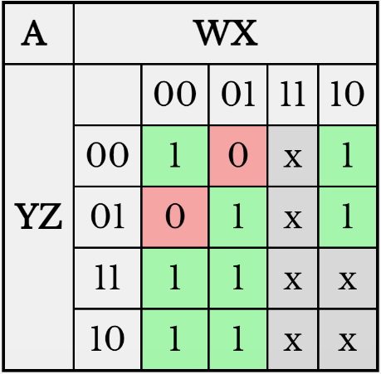
Output(A) Truth Table $F=x^{'}z^{'}+xz+w+y$
 | W | X | Y | Z | A
0 | 0 | 0 | 0 | 0 | 1
1 | 0 | 0 | 0 | 1 | 0
2 | 0 | 0 | 1 | 0 | 1
3 | 0 | 0 | 1 | 1 | 1
4 | 0 | 1 | 0 | 0 | 0
5 | 0 | 1 | 0 | 1 | 1
6 | 0 | 1 | 1 | 0 | 1
7 | 0 | 1 | 1 | 1 | 1
8 | 1 | 0 | 0 | 0 | 1
9 | 1 | 0 | 0 | 1 | 1

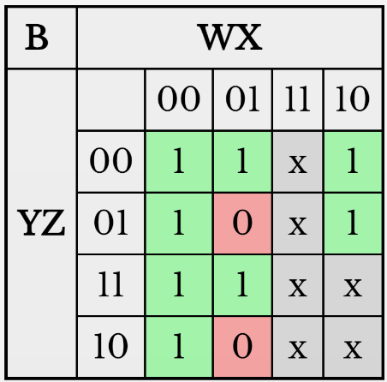
Output(B) Truth Table $F=y'z'+yz+x'+w$
 | W | X | Y | Z | B
0 | 0 | 0 | 0 | 0 | 1
1 | 0 | 0 | 0 | 1 | 1
2 | 0 | 0 | 1 | 0 | 1
3 | 0 | 0 | 1 | 1 | 1
4 | 0 | 1 | 0 | 0 | 1
5 | 0 | 1 | 0 | 1 | 0
6 | 0 | 1 | 1 | 0 | 0
7 | 0 | 1 | 1 | 1 | 1
8 | 1 | 0 | 0 | 0 | 1
9 | 1 | 0 | 0 | 1 | 1

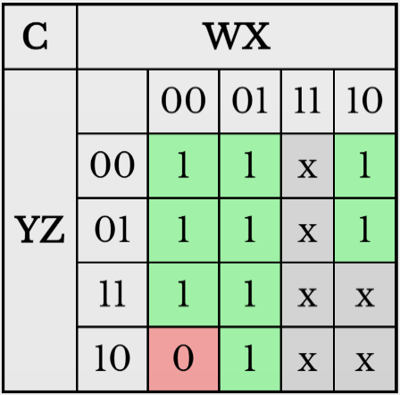
Output(C) Truth Table $F=y^{'}+x+w+z$
 | W | X | Y | Z | C
0 | 0 | 0 | 0 | 0 | 1
1 | 0 | 0 | 0 | 1 | 1
2 | 0 | 0 | 1 | 0 | 0
3 | 0 | 0 | 1 | 1 | 1
4 | 0 | 1 | 0 | 0 | 1
5 | 0 | 1 | 0 | 1 | 1
6 | 0 | 1 | 1 | 0 | 1
7 | 0 | 1 | 1 | 1 | 1
8 | 1 | 0 | 0 | 0 | 1
9 | 1 | 0 | 0 | 1 | 1

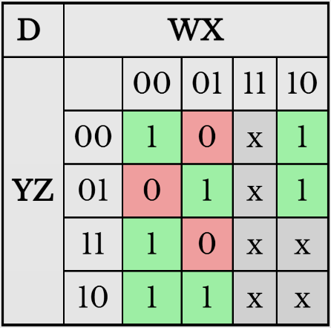
Output(D) Truth Table $F=xy^{'}z+x^{'}z^{'}+x^{'}y+yz^{'}+w$
 | W | X | Y | Z | D
0 | 0 | 0 | 0 | 0 | 1
1 | 0 | 0 | 0 | 1 | 0
2 | 0 | 0 | 1 | 0 | 1
3 | 0 | 0 | 1 | 1 | 1
4 | 0 | 1 | 0 | 0 | 0
5 | 0 | 1 | 0 | 1 | 1
6 | 0 | 1 | 1 | 0 | 1
7 | 0 | 1 | 1 | 1 | 0
8 | 1 | 0 | 0 | 0 | 1
9 | 1 | 0 | 0 | 1 | 1
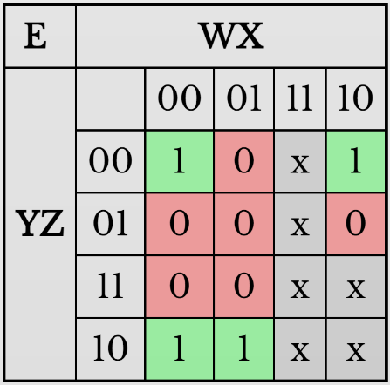
Output(E) Truth Table $F=x^{'}z^{'}+yz'+wz'$
 | W | X | Y | Z | E
0 | 0 | 0 | 0 | 0 | 1
1 | 0 | 0 | 0 | 1 | 0
2 | 0 | 0 | 1 | 0 | 1
3 | 0 | 0 | 1 | 1 | 0
4 | 0 | 1 | 0 | 0 | 0
5 | 0 | 1 | 0 | 1 | 0
6 | 0 | 1 | 1 | 0 | 1
7 | 0 | 1 | 1 | 1 | 0
8 | 1 | 0 | 0 | 0 | 1
9 | 1 | 0 | 0 | 1 | 0

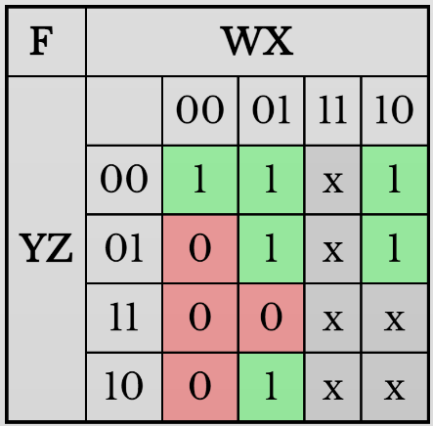
Output(F) Truth Table $F=y^{'}z^{'}+xy^{'}+xz^{'}+w$
 | W | X | Y | Z | F
0 | 0 | 0 | 0 | 0 | 1
1 | 0 | 0 | 0 | 1 | 0
2 | 0 | 0 | 1 | 0 | 0
3 | 0 | 0 | 1 | 1 | 0
4 | 0 | 1 | 0 | 0 | 1
5 | 0 | 1 | 0 | 1 | 1
6 | 0 | 1 | 1 | 0 | 1
7 | 0 | 1 | 1 | 1 | 0
8 | 1 | 0 | 0 | 0 | 1
9 | 1 | 0 | 0 | 1 | 1

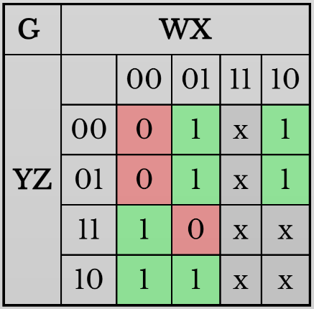
Output(G) Truth Table $F=x^{'}y+xy^{'}+yz^{'}+xz^{'}+w$
 | W | X | Y | Z | G
0 | 0 | 0 | 0 | 0 | 0
1 | 0 | 0 | 0 | 1 | 0
2 | 0 | 0 | 1 | 0 | 1
3 | 0 | 0 | 1 | 1 | 1
4 | 0 | 1 | 0 | 0 | 1
5 | 0 | 1 | 0 | 1 | 1
6 | 0 | 1 | 1 | 0 | 1
7 | 0 | 1 | 1 | 1 | 0
8 | 1 | 0 | 0 | 0 | 1
9 | 1 | 0 | 0 | 1 | 1
Diagram of Whole Circuit:
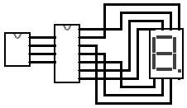

Diagram of 7 segment display controller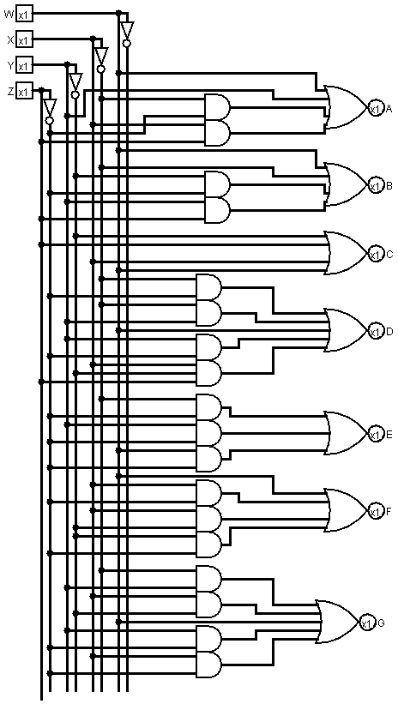

Diagram of clock, It ticks to 9, then goes back to 0
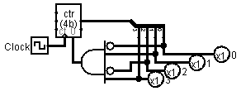
Uses a counter with a “clock” to increment it, has a splitter to split the signal to 4 bits, and has an AND to reset it when it gets to 9

